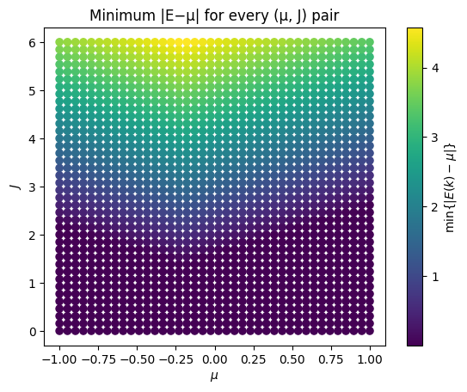
To the right is for a meshgrid of 62 points along each of the k-axes.

Below is a zoom on µ=-0.25 with 201 points along each k-axis in the meshgrid.
One line really doesn’t make sense, so see plot below.
It looks like they approximately agree that the bands become fully gapped at around J=1.4~1.5.

My lowest order integration doesn’t give 0 here!

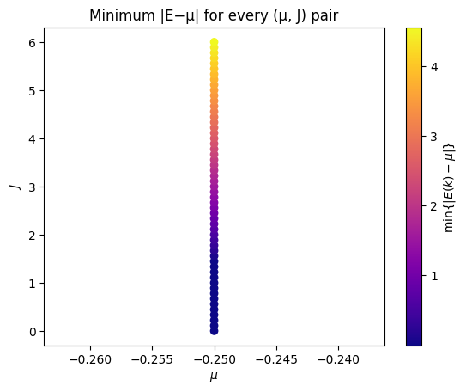
It seems, however, to change directions around this point.
I do not know if the full order integration would yield different results here.
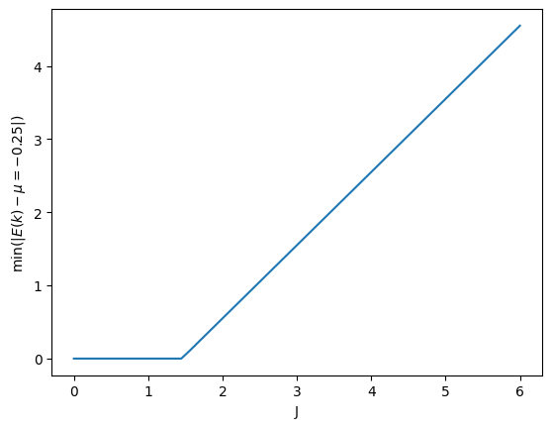
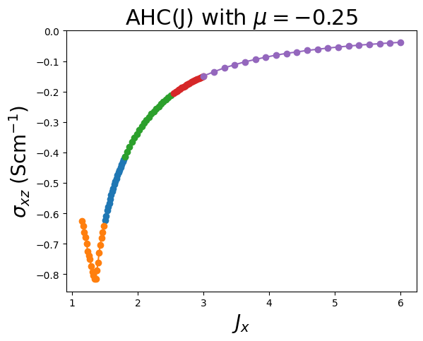
Test: integrate the full order with high precision in the range J=1.1-1.7?

